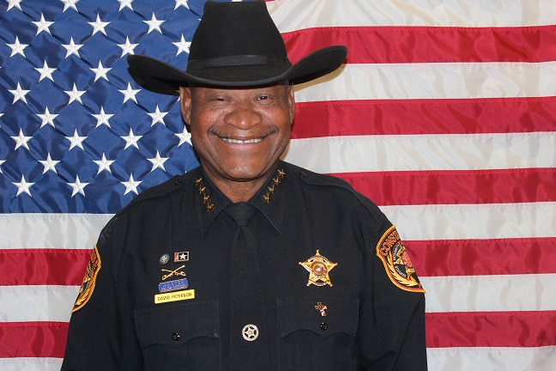
Biography

David Peterson is a long time resident of Hays County. David raised three boys and one girl. David grew up in a family of eleven kids in the San Marcos area of Texas. His vast law enforcement experience of over thirty two years has greatly instilled David’s belief in the importance of responsive and trustworthy law enforcement.
David has witnessed first-hand the importance of serving diverse communities in our precinct of all ethnic backgrounds and people from across party lines, each with their own community and culture. David will use his law enforcement and business experience to improve the performance and accountability in the Precinct 1 Constable's office and on the streets.
​​David believes that leadership starts at the top with a Constable who is dedicated to his duties and performs them effectively and efficiently. He is committed to community service, professionalism, integrity and trust. He will continue to promote and encourage the same qualities within the staff of the Constable's office.
As your Constable, he will lead this office with dedication and commitment. He will build and restore relationships between the public and law enforcement. Our relationship will create transparency that we can all be proud of.
- Born in San Marcos, Texas
- Graduated from San Marcos School in 1974
- Hays County Sheriff's Law Enforcement Academy in 1989
- Southwest Law Enforcement Academy 1985
- 32 years of Law Enforcement experience
Experience and Certifications:
- Constable Leadership College Module, I, II, III at Blackwood Lemit
- Certified Master Peace Officer
- First Line Supervisor Training
- Instructor Proficiency
- Filed Training Officer
- Mental Health Officer
- Court Security Certified
- Jailer Certificate
- Previous Mounted Patrol Officer (HCSO)
- Previous Warrant Officer (HCSO)
- Previous Sergeant of Patrol (HCSO)

Organization Membership & Community Involvement:
- Member of the Juneteenth Foundation
- Member of the Schibe Board
- Member of the Lulac Club
- Member of NWCP
- Member of the Lions Club
- Member of the Justice of the Peace & Constables Association
- Member of the Central Justice of the peace and Constables Association
- Community Involvement with the Cinco De Mayo
- Community involvement with the Casa Program
- Community Involvement with Mendez Elementary School
- Previous Member of MOPS

