Hays County Constable Precinct 1___________________________________________
Constable David Peterson
Mission Statement
It is the mission of the Hay County Constable Pct. 1 Office to always maintain an efficient, professional, sensitive, compassionate and respectful manner while executing our responsibilities as peace officers in the State of Texas.
It is the mission of the Hays County Constable Pct. 1 Office to be well-trained through continued education in all areas of law enforcement, as well as in the areas of protection of the public, sensitivity and diversity.
It is the mission of the Hays County Constable Pct. 1 Office to continue making our communities a safer place to live, work and raise a family.
Constable Duties:
- To assist the Justice of the Peace
- To serve Criminal and Civil Process
- To assist other law enforcement agencies

Meet Hays County Constable Precinct 1

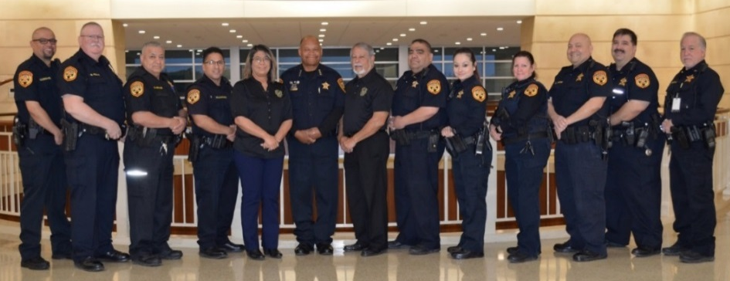
Meet Hays County Constable Precinct 1

Next Tax Sale Date 04/02/2019
10:00 am @ 712 S. Stagecoach Trail Suite 2210
San Marcos, Texas 78644 Entrance Steps

For a listing of Hays County properties being sold for delinquent taxes
or for information about the sale process
visit the website of
Linebarger Goggan Blair & Sampson, LLP at
http://www.publicans.com/services/tax_sales.htm

