Constable Precinct One Command Staff

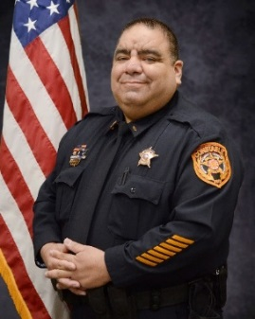
23 years Law Enforcement
Over 2200 hours of TCOLE training
Master Peace Officer
Instructor Certified
Field Training Officer
Civil Process Proficiency
Internal Affairs Investigator
Previous Corporal Warrant Officer (WLPD) and TCCO Pct. 2)
Previous Corporal (WLPD and TCCO PCT 2)
Previous Sergeant (TCCO PCT 2)
Previous Lieutenant (TCCO PCT 2)

Chief Michael Varela

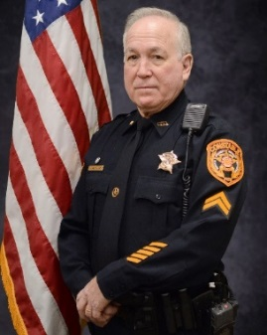
8.5 years Law Enforcement
11.6 Corrections
Over 1450 hours of TCOLE training
Intermediate Peace Officer, Instructor Certified
Field Training Officer, Mental Health Officer
Standard Field Sobriety Testing Certified
School Resource Officer Certified
Court Security Officer Certified
Civil Process Certified
Jailer Certificate, Warrant Officer
Corporal for Constable
Previous Corporal for Support Services (HCSO)
Previous Mounted Patrol (HCSO)

Corporal Frank Cheatham

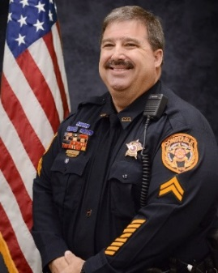
25 years Law Enforcement
Over 2500 hours of TCOLE training
Master Peace Officer
Mental Health Officer
Instructor Certified
Firearms Instructor
Field Training Officer
Previous Senior Patrol Officer ( SVPD)
Previous DARE Officer (SVPD 8 Years)
Court Security Officer Certified

Corporal Greg Grumbles

Hays County Precinct One Deputy Constables

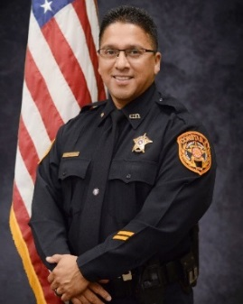

6 years Law Enforcement
4 years Corrections
Over 1600 hours of TCOLE training
Intermediate Peace Officer
Field Training Officer
Standard Field Sobriety Testing Certified
Bilingual
Jailer Certificate

Senior Deputy Eric Villalpando

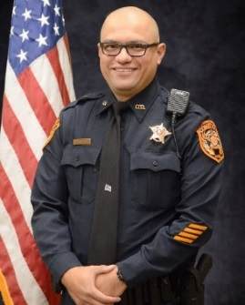

12years Law Enforcement
Over 5700 hours of TCOLE training
Master Peace Officer
Field Training Officer
Bilingual
Texas State University Graduate BSCJ-2001

Deputy Ramiro Almendarez

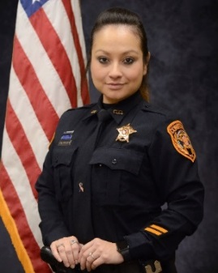
6 years Law Enforcement
Over 1358 hours of TCOLE training
3 Years Tele communicator
Field Training Officer
Bilingual

Deputy Jessica Ryan Deatherage

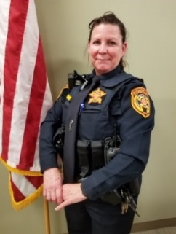
4 years Law Enforcement
Over 970 hours of TCOLE training
Basic Peace Officer
Mental Health Officer
Certified Court Security Officer
Jailers Certification
1 Year Reserve Deputy
Previous Animal Control Supervisor City of San Marcos

Deputy Bailiff Carol Cooley

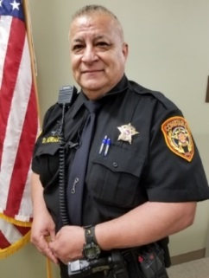
3 years Law Enforcement
Over 1308 hours of TCOLE training
8 Years Texas Dept. Private Security Level 3 Comm. Officer
6 years Court Bailiff
Jailer Certificate
Bilingual

Deputy Bailiff David Morales

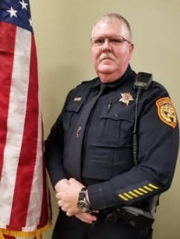
28+ years of Law Enforcement
Over 2600 hours of TCOLE training
Master Peace Officer
Instructor Certified
Mental Health Officer
Previous Detective (SMPD)
Previous SRO (SMPD)
Previous Field Training Officer (SMPD)
Previous Fatality Accident Investigator (SMPD)
Previous Deputy Sheriff (Kerr County S.O.)
Previous Reserve Deputy Sheriff (Erath County S.O.)

Deputy Bailiff Brad Follis

Hays County Constable Precinct One Reserve Deputies

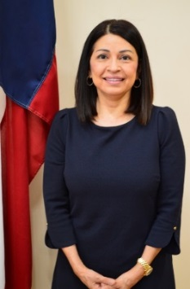
2 years Law Enforcement
22 Years Reserve Deputy
Over 1205 hours of TCOLE training
Master Peace Officer
Advance Pearce Officer
Texas State University

Reserve Deputy Debbie Ingalsbe

27 years Law Enforcement
Over 3027 TCOLE Training
Masters of Science in Criminal Justice – Lamar University
Bachelor of Arts in University Studies- Texas Tech University
Associate of Arts in Social &Behavioral Studies- South Texas College
Associate of arts in Interdisciplinary Studies- South Texas College
Master Peace Officer
Basic Instructor
Firearms Instructor
Mental Health Peace officer
Trade and Industrial Education Classroom Teacher
Adjunct Police Academy Instructor

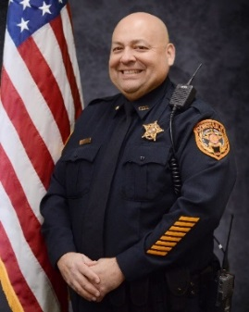
Reserve Deputy Javier J. Castro

Hays County Constable Precinct One Justice Clerks

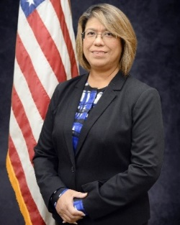
Rhoda Chavira – Office Administrator
5 years of service – Constable D. Peterson
27 years County Government
Previous 10 years Justice of the Peace Chief Clerk, Justice Clerk (Caldwell Co)
Bilingual
Civil Process Proficiency Certification

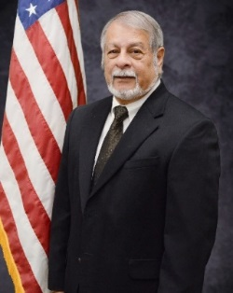
Joe Lucio – Justice Clerk

4 years of service – Constable D. Peterson
3 years book keeping experience
8 years US Treasury Clerical experience
Navy Military Veteran
Texas State – B.B.A.
Bilingual

